Series convened by
Rev Dr Jonathan Barker

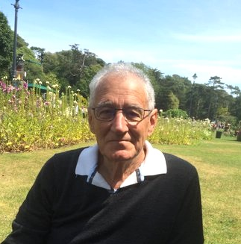

Participants will be invited to share
in collaborative leadership of the series.
We shall reflect together
sociologically and theologically.
The setting will foster an honest enquiry into the topic and encourage participants
to seek ways forward
for the future of the planet.

SPONSORED BY PCNet
The Progressive Christianity Network
A task force of the Effective Living Centre
which is a project of Christ Church Uniting



The Sessions

1. March 1st or 2nd

The Self Worshipper
and the Terminator
Social pioneering

2. March 8th or 9th

The Degrader
and the Butcher
Acting on behalf of

3. March 15th or 16th

The Baker
and the Poisoner
Repenting for society

4. March 22nd or 23rd

The Devourer
and the Urbanite
Changing oneself

5. March 29th or March 30th

The Self Deceiver
and the Getting of Wisdom
Reduplicating the deed of Christ

A Different Kind of Lenten Series for 2017

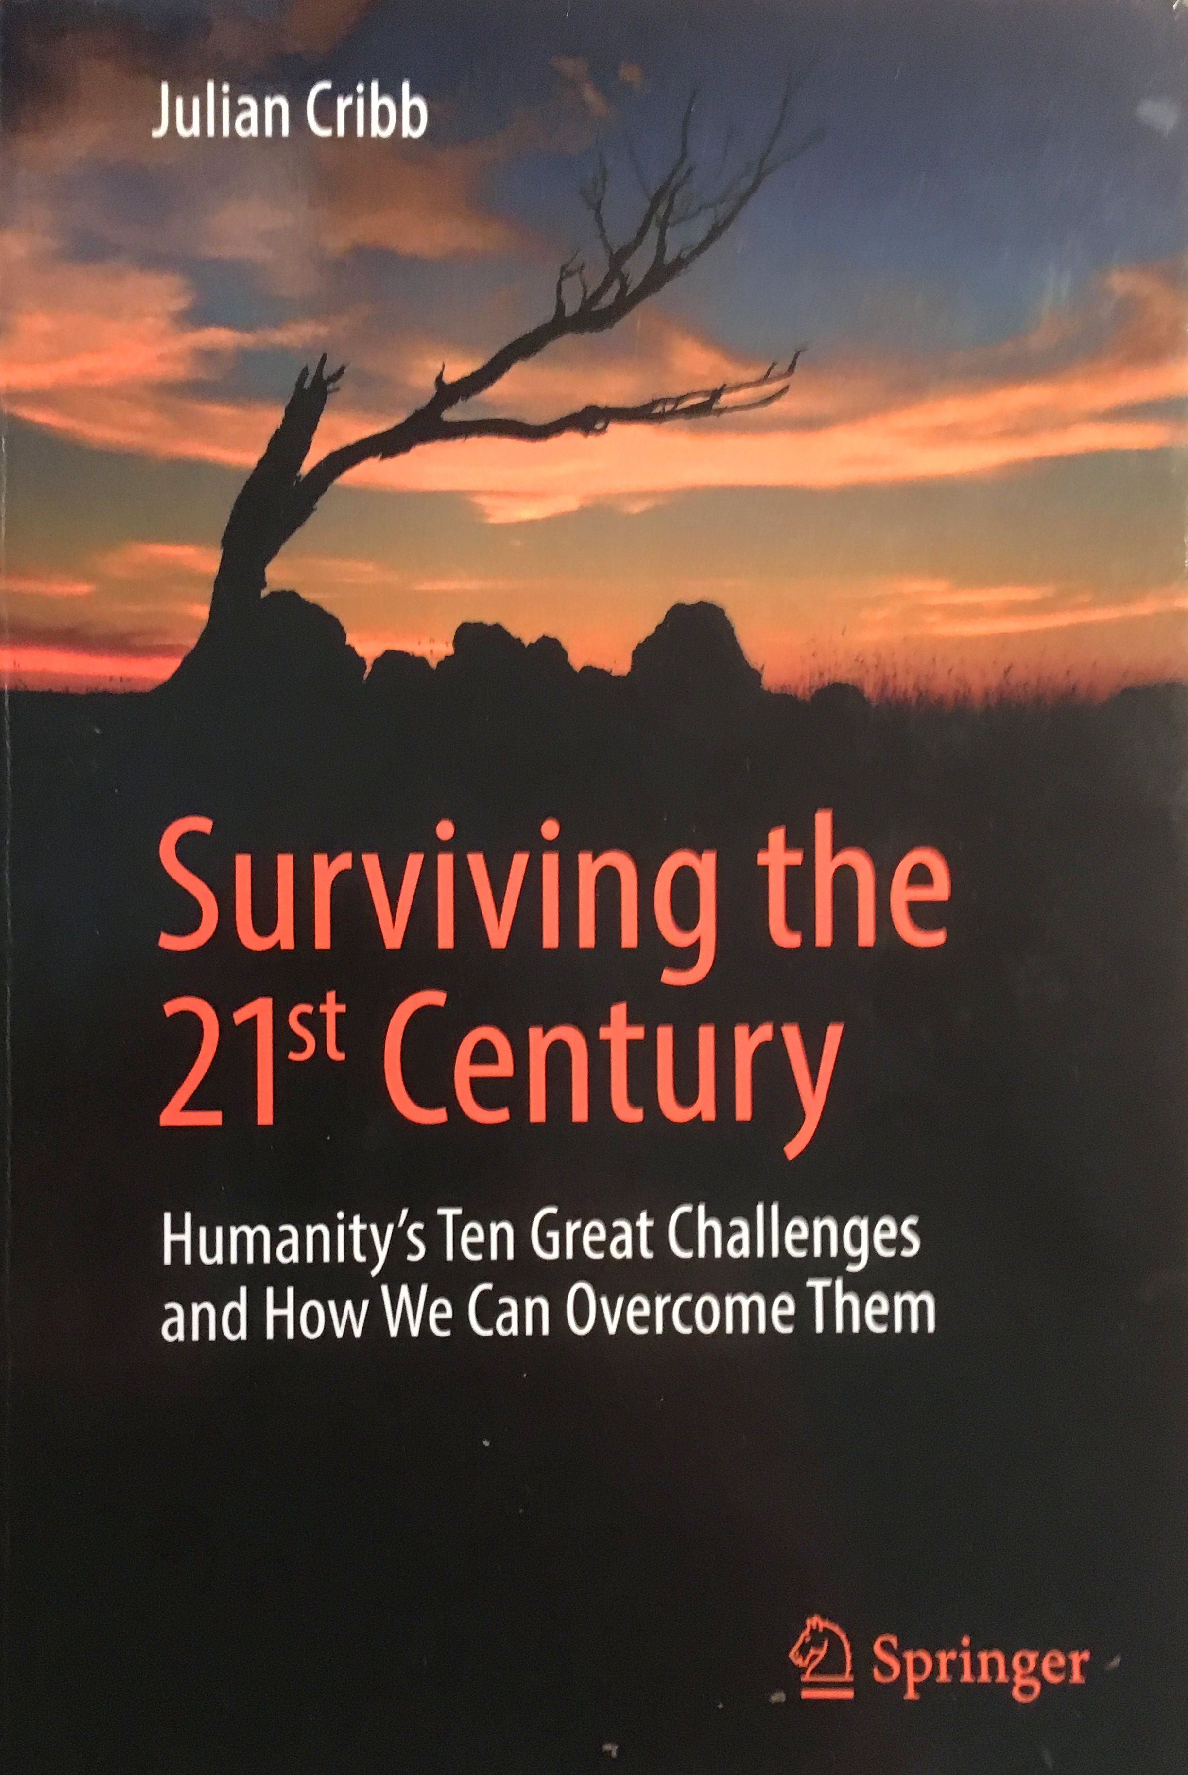

An invitation is extended to all who
recognise that all life on the planet
is in danger of extinction.
How is the earth to be saved?

MORIALTA UNITING CHURCH
Wednesday evenings
1st March to 29th March 7 pm to 9 pm

CHRIST CHURCH UNITING CHURCH
Thursday mornings
2nd March to 30th March 10 am to 12 noon

EXTINCTION OR RESURRECTION
OF THE PLANET?



In his book Julian Cribb examines ten intersecting areas of activity (mass extinction, resource depletion, WMD, climate change, universal toxicity, food crises, population and urban expansion, pandemic disease, dangerous new technologies and self-delusion) which pose manifest risks to civilisation and potentially to the long-term future of our species.

This isn’t a book just about problems. It is also about solutions. Every chapter concludes with clear conclusions and consensus advice on what needs to be done at global level - but it also empowers individuals with what they can do for themselves to make a difference. Unlike other books, it offers integrated solutions across the areas of greatest risk.

In parallel we shall consider the role of the church as social pioneer using
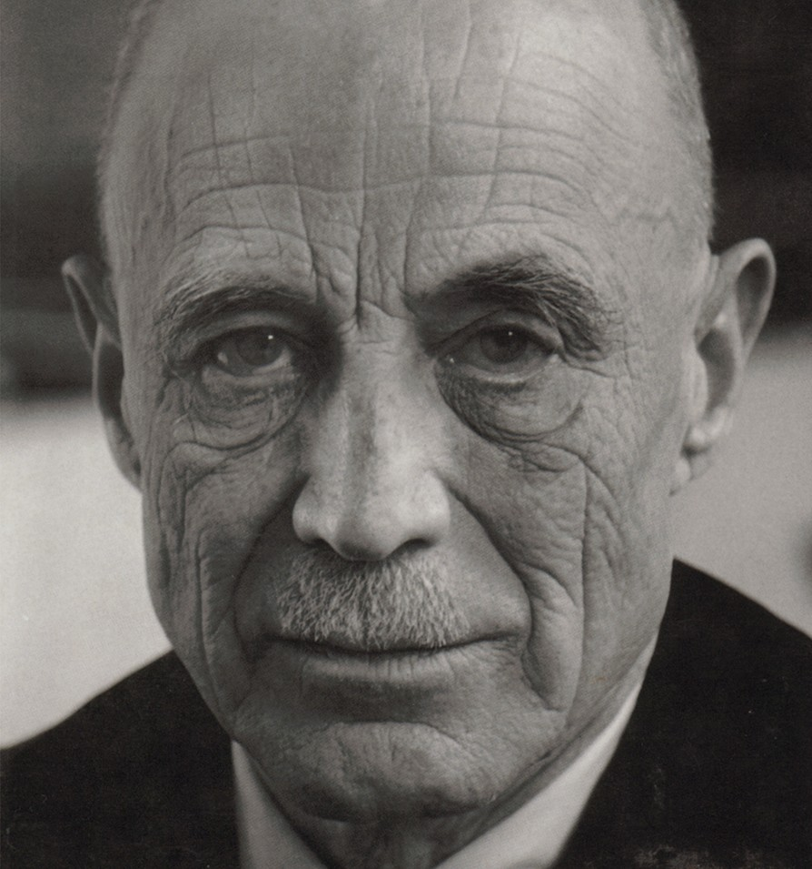
H. Richard Niebuhr’s essay on the Church as Social Pioneer. This is a classic text of the mid 20th century, written in the wake of World War II when humanity had to face up to the
social “evils” of the times. He dares to suggest that the church truly fulfills its purpose when it acts as a social pioneer.

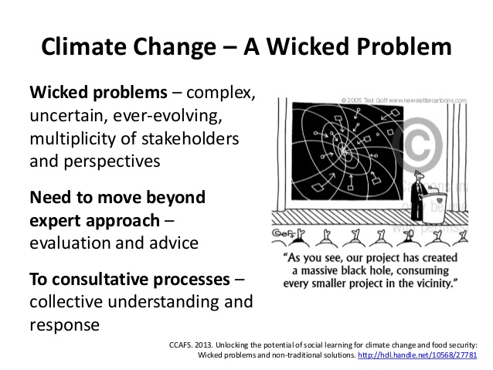

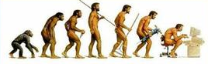

REGISTRATION

People may register on site at:

Morialta Uniting Church
8331 9344

Christ Church – ELC Wayville
8271 0329

Other registrations can be made by post:
to The Effective Living Centre
26 King William Road
Wayville S.A. 5034

Name …………………………………….

Address …….…………………………..

…………………………………………….

Phone ……………………………………..

Email ……………………………………….

Registrations can also me made through
www.effectiveliving.org
and follow the prompts to TryBooking

It is essential to have a copy of the book
Books can be purchased direct through
Book Depository for $35 (free shipping!)
OR
PCNet has purchased 15 copies
for sale – enquire at the ELC office

